Economics and Ergodicity

This month, I came across a very interesting article about a proposed resolution to what the author regards as a long standing problem in economics. The basic point of the paper, which is entitled The ergodicity problem in economics by Ole Peters (Nature Physics, Vol. 15, December 2019) is that classical economic analysis is fundamentally flawed. According to Peters, the fatal mistake made for hundreds of years is the ergodic assumption that equates the time average of an economic process (say investing) by an individual to the average of the same process across an entire population, at a given time. Determining whether this assumption holds is extremely important if economists want to be able to model what the average person will do.

Ergodicity is a concept originating in the branch of physics known as statistical mechanics. Statistical mechanics seeks to characterize physical systems that possess vast numbers of moving parts in terms of a vastly smaller set of parameters. Evolution of a complex system is generally described in terms of how the averages and standard deviations associated with all these parts change in time. By assuming that the system is ergodic, the physicist can state how a system will evolve in time simply by looking at the average over multiple copies of the system at an instant in time.

An example will help make some of these ideas more concrete. A typical ‘simple’ physical system with a vast number of moving parts is a bottle of water. Describing this bottle of water at the supermarket is absurdly simple, one merely specifies the amount of fluid (250 ml, 500 ml, etc.) and the temperature. If one wanted to be fancy, one could even specify the percentages of trace elements bringing the number of parameters, say, up to 100. Despite the fact that 100 is a relatively large number of things to track, it’s still vastly smaller than the number of parameters needed to describe the bottle at a molecular level. In a 500 ml bottle, there are approximately 1.86 x 10^25 water molecules or about 9.3 trillion trillion molecules for each dollar of federal debt and each requires, at a minimum, 7 numbers to describe its motion.

Once the bottle is bought and brought home, it will have its own local history. It may be placed in the refrigerator or left in a hot car; it may be opened and partially or totally drained or kept shut for a later consumption; and so on. Ergodicity assumes that each of the bottle’s observed states, as it evolves in time, can be matched with a single bottle in a large population of differently prepared bottles at a given time. An unopened 500 ml bottle that warms from 5 to 20 C can be thought of as first visiting the state of an identically-sized bottle that is held at 5 C, then a different 500 ml bottle held at 5.5 C, then yet another bottle of the same size held at 6 C, and so on. In this way the time average of the single bottle’s temperature can be derived from an average over a population or ensemble of bottles each kept constant at its own particular temperature. Alternatively, the large population’s statistics may be derived by taking a time average of a single member. Which direction (time-to-ensemble or ensemble-to-time) depends on the physical system and the experiments being performed.

The ergodicity assumption has been quite successful in thermodynamics but Peters contention is that the types of dynamical systems found in an economy do not share this feature with the dynamical systems found in nature. To support this claim, he offers a simple gambling model that will be explored in the rest of this column.

In Peters’s model, a person can participate in a repeated wager where 50% of the time he may increase his wealth by half and the other 50% of the time he will lose 40% of all that he has. According to Peters, classic economics would predict that the potential gambler would jump at this chance. The gambler’s enthusiasm derives from his analysis, using classical concepts from economics, the fact that the expectation value for this gamble (average gain or loss, denoted by E(gamble)) would result in a 5% gain since

< E(gamble) = Prob(win) Payoff(win) + Prob(loss) Payoff(loss) = 0.5 ( 0.5 - 0.4 ) = 0.05 ,>

where the notation Prob(win/loss) = probability of winning or losing (0.5 for both), Payoff(win/loss) = the outcome of a win or a loss (0.5 or -0.4 for a win or loss, respectively).

Peters points out that no rational person would actually agree to this gamble and thus the disconnect, he argues, between classical economic predictions and observed participation in the economy. This is where ergodicity comes in. Basically, the average person understands intuitively that this gamble, despite its constant positive expectation value as a function of time it is not ergodic. That is to say that the time average of a gambler’s wealth, assuming he repeatedly plays, doesn’t result in a roughly constant 5% increase but rather it leads to ruin.

The article presents a rather disturbing graph in which the wager is simulated as a random process for 50 members of the economy who participate in repeated goes at the same gamble. My own reproduction of this process using 150 members is shown below.

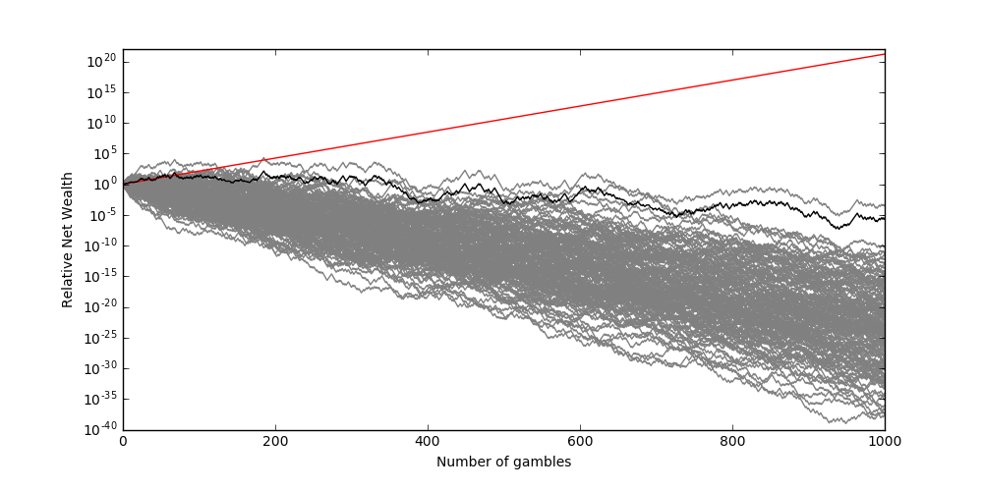

Each of the grey lines represents the time evolution of the relative wealth of a single gambler who repeatedly engages in the Peters wager. The black line is the average over all the gambles - the time evolution of the ensemble average. If ergodicity held, then this black line would equal the red line.

The bulk of Peters’ article is a sophisticated analysis why ergodicity fails to hold and under what conditions. It is a difficult read but likely very important in revising economic theory. But, regardless of how important the technical details that emerge may be, an even more important point will be understanding how the human participant, lacking all of this specialized expertise, understands to stay away from this type of gamble. Insights into this last point are likely to be more profound than the underlying mathematics.

